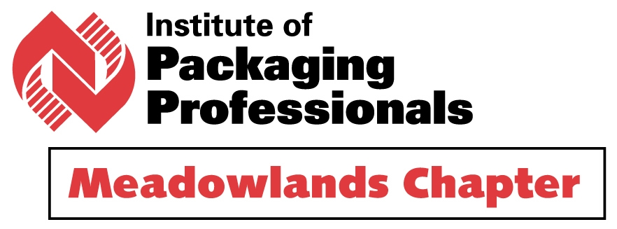

Taking Global Logistics into the Board Room
by
Mr. Matthew Foster, Business Development Mgr.
DHL Global Forwarding

Wednesday, November 11, 2015
Harold’s New York Deli
10 Polito Avenue (right off Route 17 S.)
Lyndhurst, NJ 07071 - Tel: 201-935-2600.

Dame Fortune smiles again. Through the experiences of Mr. Foster, he will take us where few have ventured – into the Board Room. Such illuminating details like rates, how and what to ship by which transportation mode and many other secrets await you.

This will be our last meeting for 2015. Take advantage of it. There is much you will learn.

Protocol is as usual. We meet at Harold’s for dinner commencing at 6:30 pm. The presentation starts at 7:30 pm until completion. The $40.00 fee includes dinner for members and non-members. Cash bar will be available. Please make your reservation with Gordon Ellis at 212-284-2695 or gellis@estee.com.

