Please Come Join Us to Celebrate
… our Heartfelt thanks
The Salvation Army
Volunteer Recognition Breakfast
Friday, February 22, 2013

7:00-7:30 a.m. – Registration & Coffee
7:30-8:30 a.m. – Program, Recognition & Breakfast

to be held at:
Italian American Heritage Center
425 North Fourth Street in San Jose
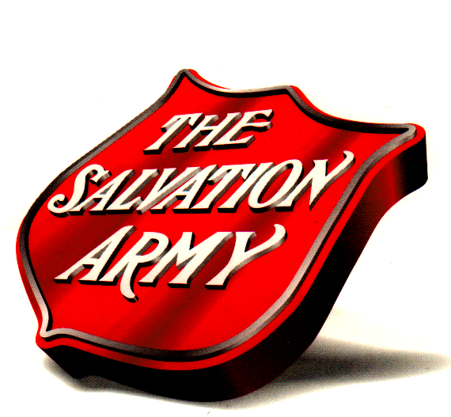
Please let us know if you will attend and how many will attend with you.
RSVP: Liwayway Gimenez by 2/15/2012
liwayway.gimenez@usw.salvationarmy.org
(408) 282-1165 ext. 3218

Complimentary Admission
Value: $15.00
(Donations not required,
but graciously accepted)
…Our Heartfelt Thanks
Volunteer Recognition Breakfast
The Salvation Army Presents:
Volunteer Recognition Breakfast

Italian American Heritage Center
425 North Fourth Street in San Jose
(408) 282-1165 ext. 3218
General Admission

Friday, February 22, 2012

